How to copy data from 3 files to three different tables

For example

Copying file from pasting to tables

Orders.csv order_tbl

Sales.csv sales_tbl

Customer.csv customer_tbl

1. Go to the database
2. Create table of filnames and table names

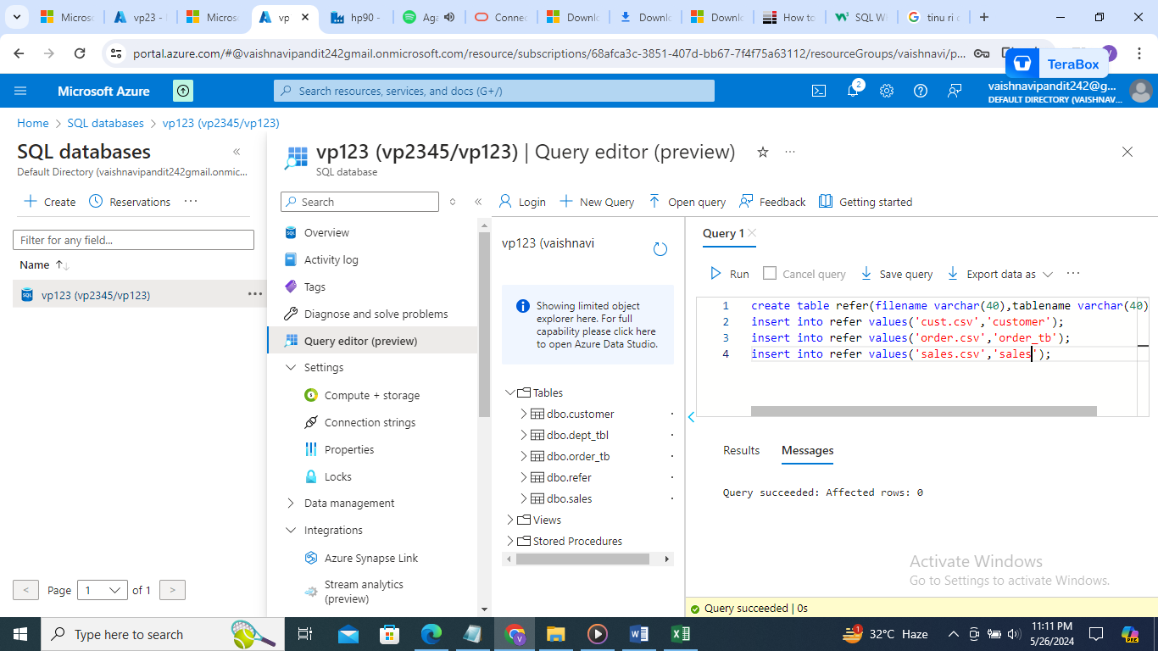

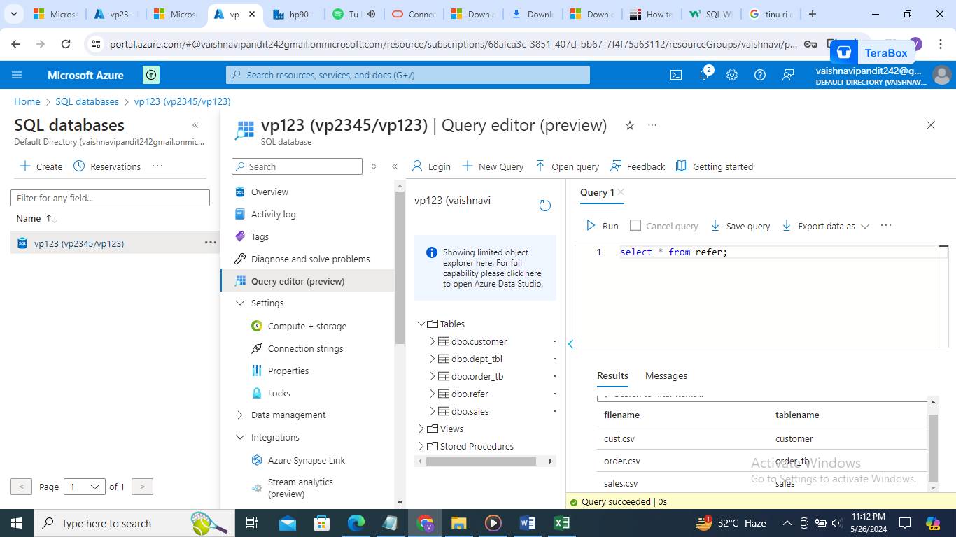

1. Now go to datafactory create lookup activity to get names of files and tables

First create dataset and linked service to connect to refer table where all the file and table names exist

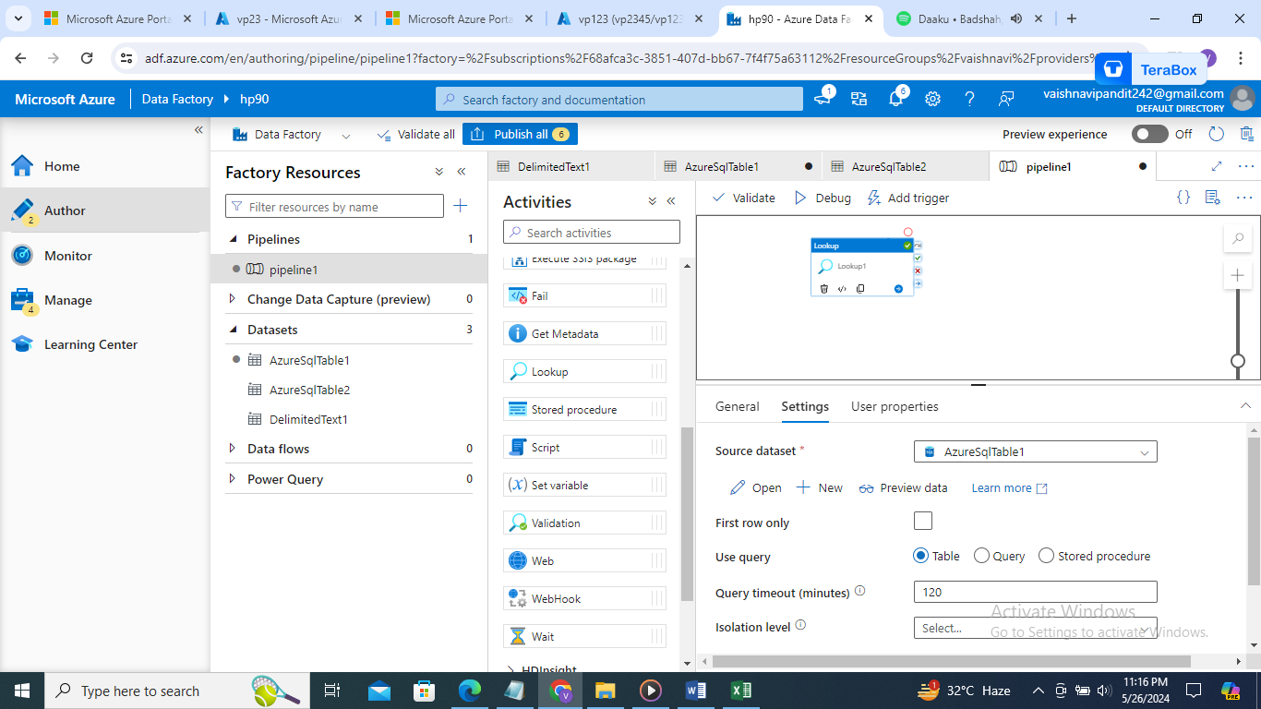

Output: array of file and table names

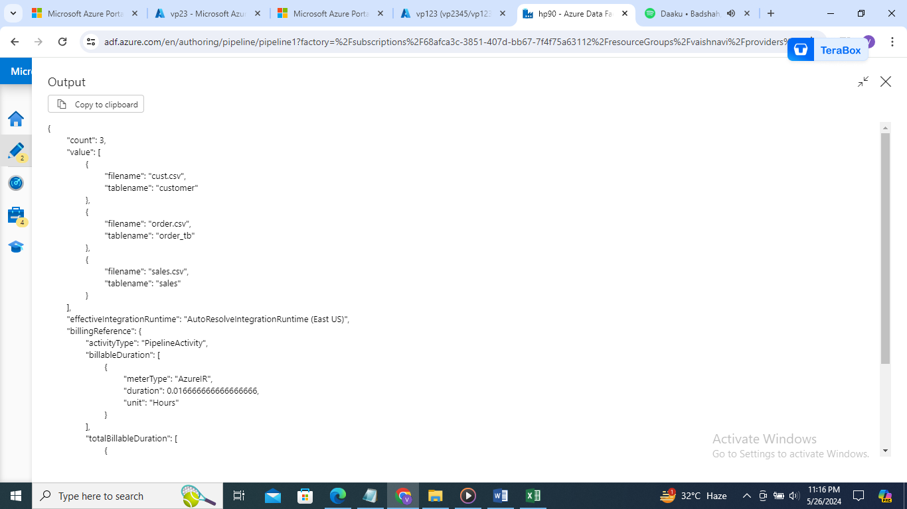

1. Now create for each activity

Select sequential

In items lookup activity output

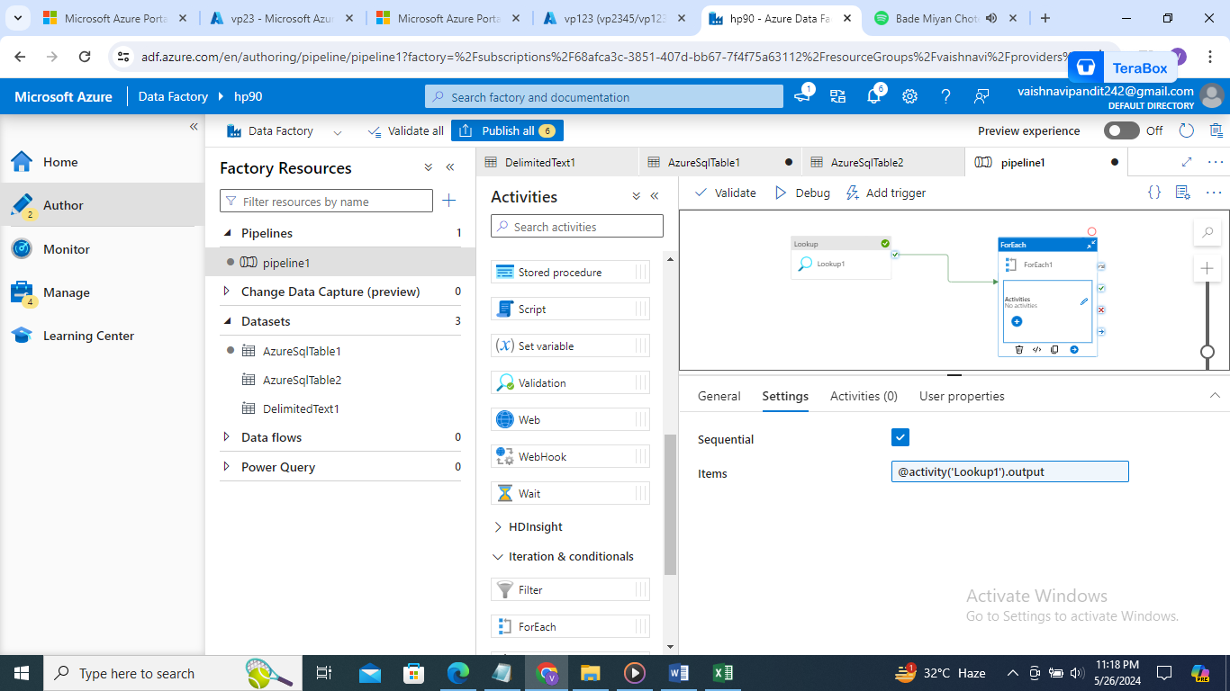

1. Now create variables for file name and table name

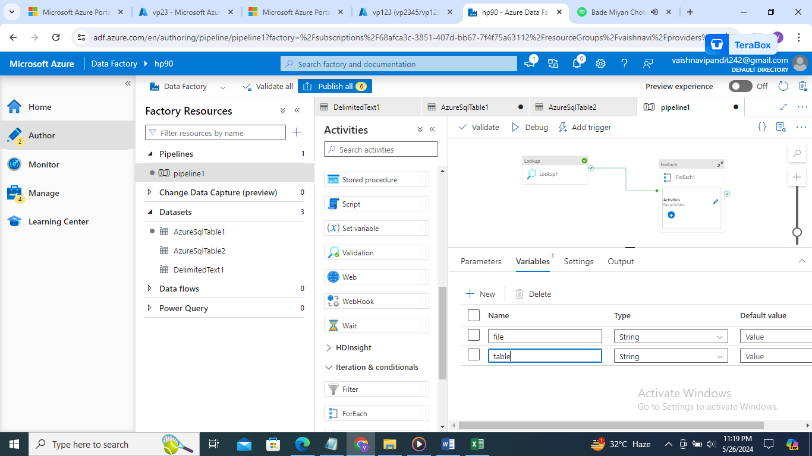

1. Now again go to the for each and create set variable activity for file name variable

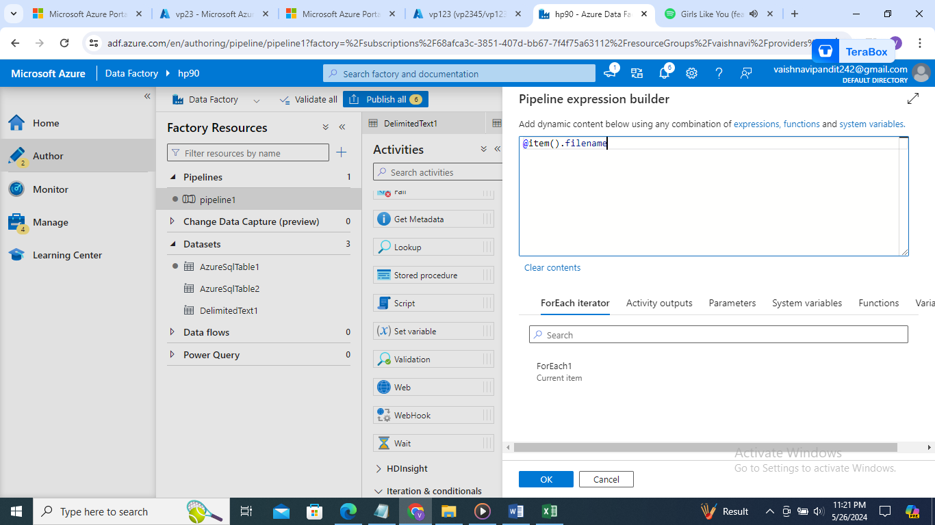

1. Similarly create for tablename

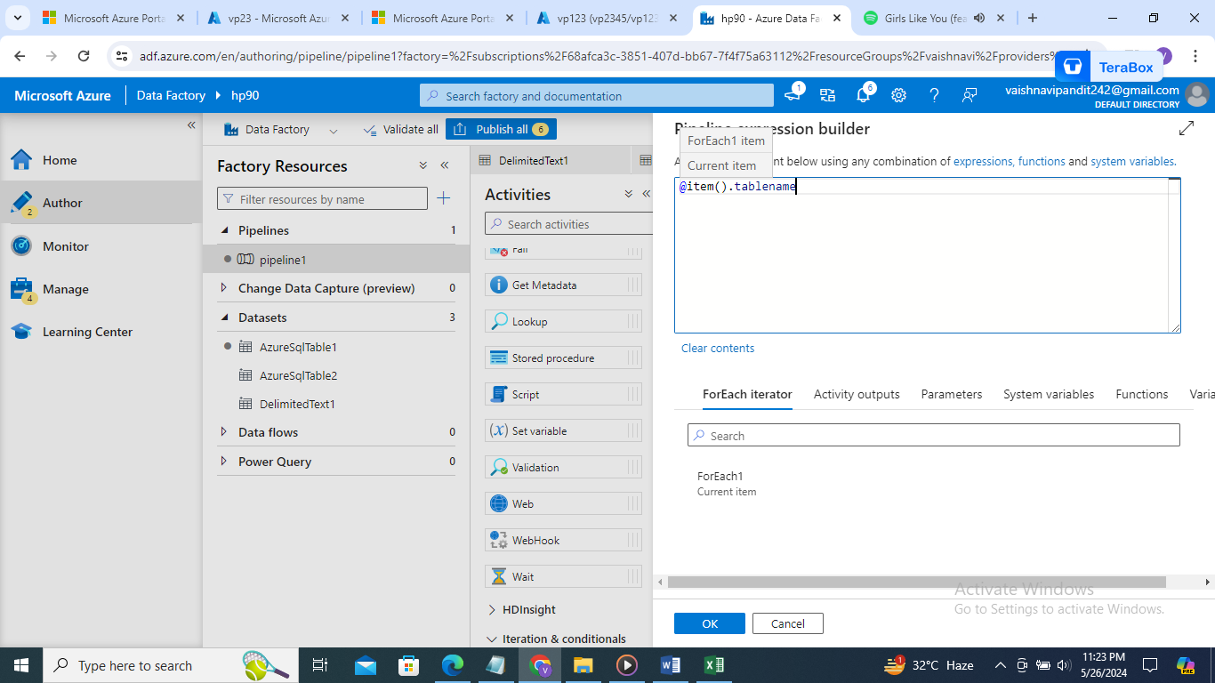

1. Now create datasets with parametes for copy activity we know how to create files in adls we will create for sql databae

Got to datset ->create->sql database->add name->linked service->not table name

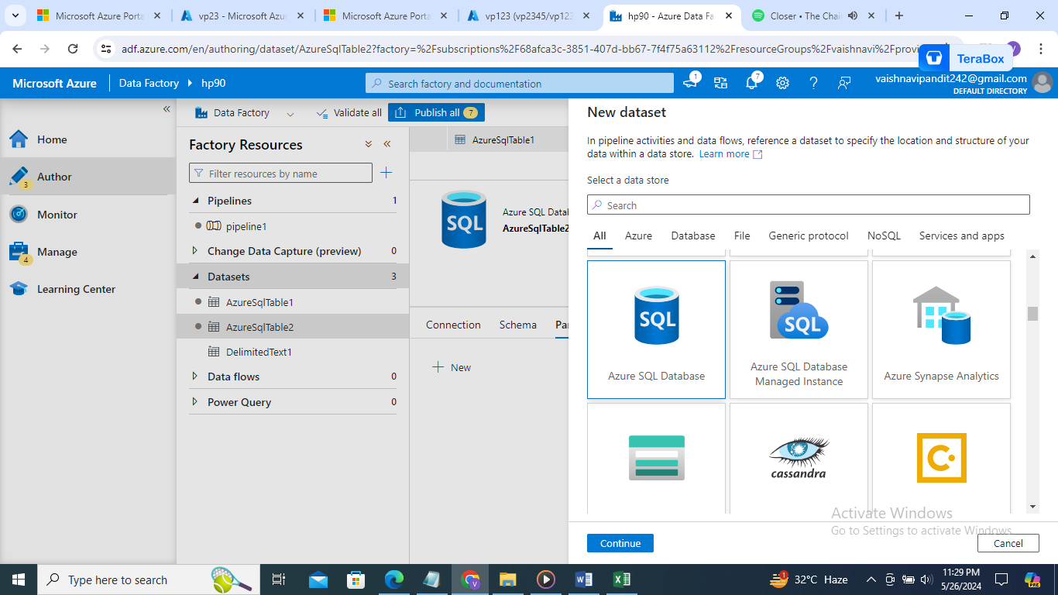

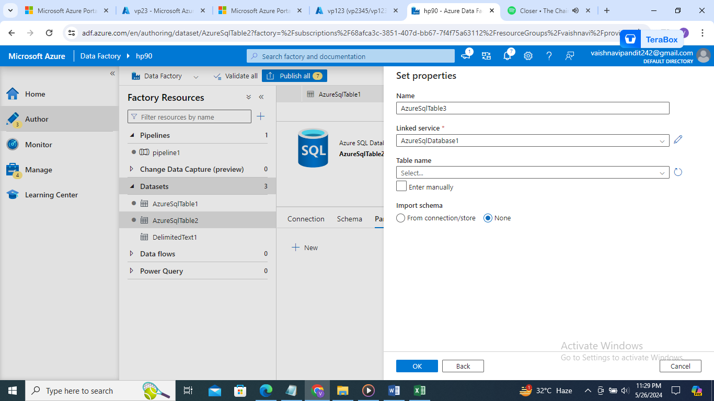

1. Now go to the parameters

Create parameter for table name

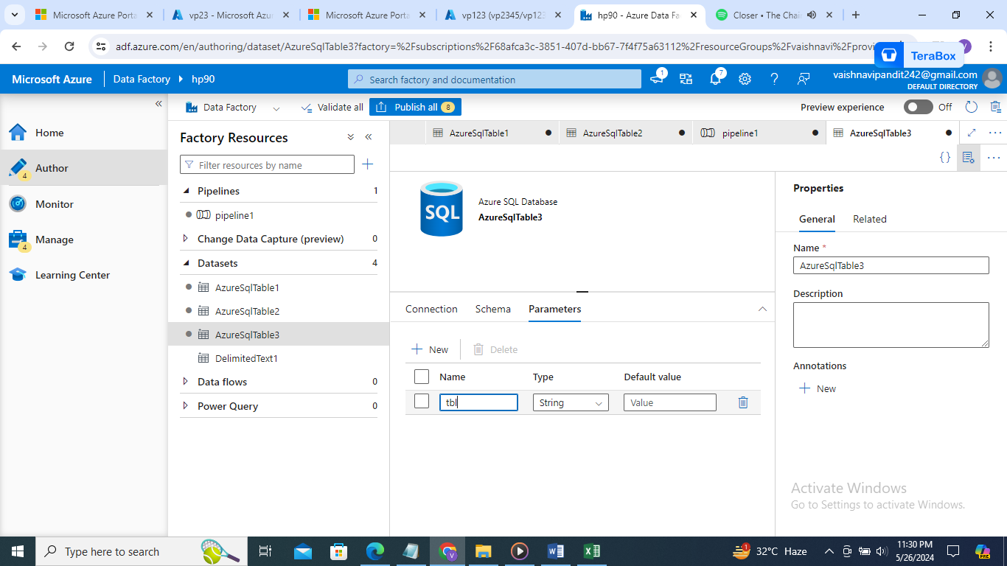

1. Now go to the connection in table name add manually

The put value dbo. Add dynamic contents and select parameter

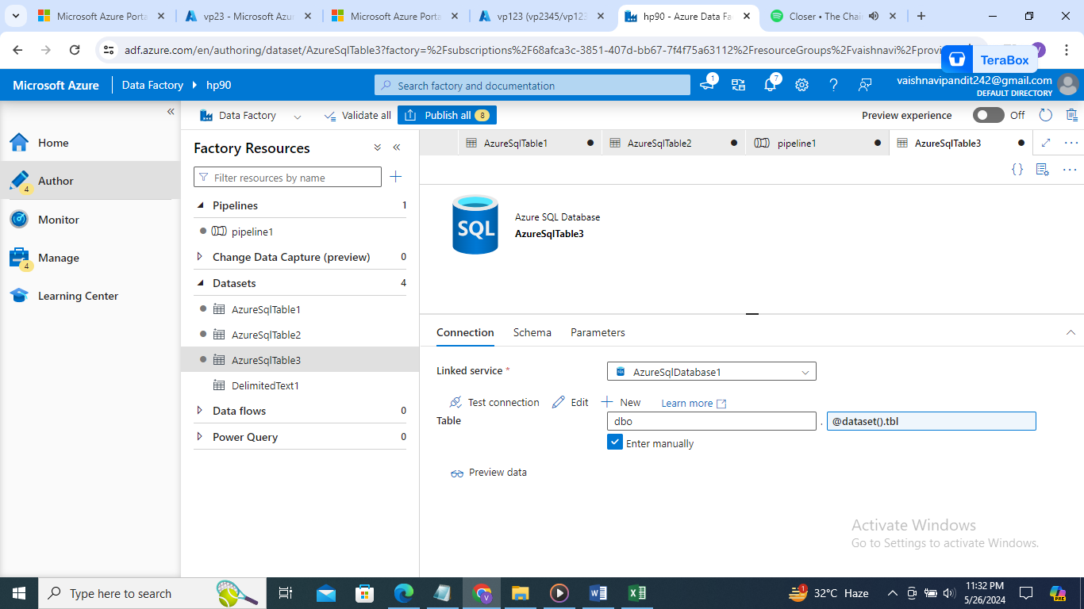

1. Now go to the copy activity in source add dataset and value filename variable

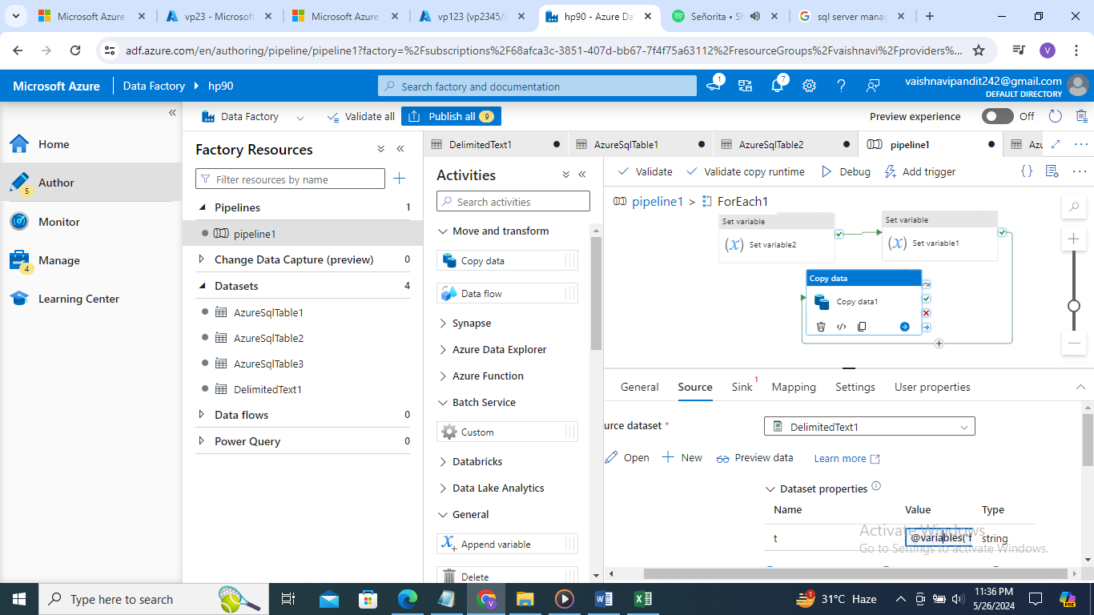

1. And in sink add dataset and value tablename

